CAREER ADVANCEMENT SKILLS
ASSIGNMENT-2
Name: Subhapreet Patro
Roll No.: 2211CS010547
Section: I
1.Application Configuration Manager, You are tasked with developing a Java-based configuration manager for a simple desktop application. The application requires loading, reading, and updating configuration settings such as username, theme, auto-save interval, and language. These settings should be stored in a .properties file and managed using Java's Properties class.

Solution:
1. Sample config.properties File
username=guest
theme=light
autoSaveInterval=5
language=en

2. ConfigManager.java - Java Code
import java.io.*;
import java.util.Properties;
import java.util.Scanner;

public class ConfigManager {
private final String configFilePath;
private final Properties properties;

public ConfigManager(String configFilePath) {
this.configFilePath = configFilePath;
this.properties = new Properties();
}

// Load properties from file
public void loadConfig() throws IOException {
File file = new File(configFilePath);
if (!file.exists()) {
System.out.println("Configuration file not found. Creating new one.");
saveDefaultConfig();
}

try (FileInputStream fis = new FileInputStream(configFilePath)) {
properties.load(fis);
}
}

// Save properties to file
public void saveConfig() throws IOException {
try (FileOutputStream fos = new FileOutputStream(configFilePath)) {
properties.store(fos, "Application Configuration");
}
}

// Save default config if file not found
private void saveDefaultConfig() throws IOException {
properties.setProperty("username", "guest");
properties.setProperty("theme", "light");
properties.setProperty("autoSaveInterval", "5");
properties.setProperty("language", "en");
saveConfig();
}

// Getter method
public String getSetting(String key) {
return properties.getProperty(key);
}

// Setter method
public void updateSetting(String key, String value) {
properties.setProperty(key, value);
}

// Display current settings
public void printSettings() {
System.out.println("Current Configuration:");
for (String key : properties.stringPropertyNames()) {
System.out.println(key + " = " + properties.getProperty(key));
}
}

// Main method for demonstration
public static void main(String[] args) {
String path = "config.properties";
ConfigManager manager = new ConfigManager(path);
Scanner scanner = new Scanner(System.in);

try {
manager.loadConfig();
manager.printSettings();

System.out.println("\nDo you want to update a setting? (yes/no)");
if (scanner.nextLine().equalsIgnoreCase("yes")) {
System.out.print("Enter setting key: ");
String key = scanner.nextLine();
System.out.print("Enter new value: ");
String value = scanner.nextLine();
manager.updateSetting(key, value);
manager.saveConfig();
System.out.println("Configuration updated successfully.\n");
manager.printSettings();
}
} catch (IOException e) {
System.err.println("Error managing configuration: " + e.getMessage());
}
}
}

Output:
First Run (when config.properties doesn't exist):
Configuration file not found. Creating new one.
Current Configuration:
username = guest
theme = light
autoSaveInterval = 5
language = en

Do you want to update a setting? (yes/no)
yes
Enter setting key: theme
Enter new value: dark
Configuration updated successfully.

Current Configuration:
username = guest
theme = dark
autoSaveInterval = 5
language = en

File Output (config.properties after update)
#Application Configuration
#Mon Jul 28 10:02:34 IST 2025
username=guest
theme=dark
autoSaveInterval=5
language=en

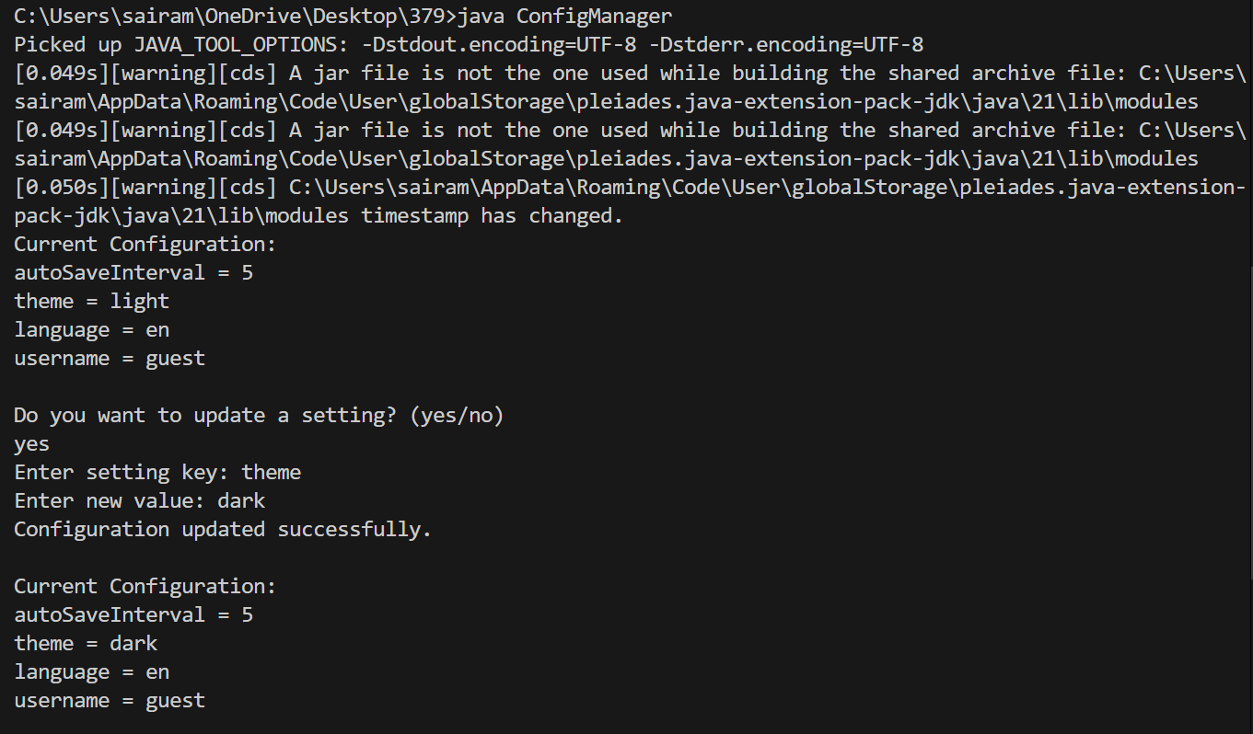

2.How to implement collection ordering?
Solution:
1. Using TreeSet (for Sorted Sets)
- Automatically sorts elements in natural order or using a custom comparator.
Example:
import java.util.*;
public class TreeSetExample {
public static void main(String[] args) {
System.out.println("Subhapreet Patro: 2211CS010547");
Set<String> names = new TreeSet<>();
names.add("John");
names.add("Alice");
names.add("Bob");
for (String name : names) {
System.out.println(name); // Output: Alice, Bob, John (sorted)
}
}
}

Output:
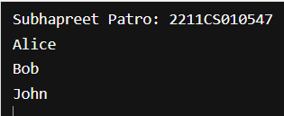

3.Word Frequency Counter (Map & Set)
Write a Java program that reads a paragraph of text and prints the frequency of each unique word in descending order of frequency.
Requirements:
• Ignore case and punctuation.
• Use HashMap to count words.
• Use TreeMap or sorting logic to sort by frequency.
• Use Set to handle unique words.

Solution:
import java.util.ArrayList;
import java.util.HashMap;
import java.util.HashSet;
import java.util.List;
import java.util.Map;
import java.util.Scanner;
import java.util.Set;

public class WordFrequencyCounter {

public static void main(String[] args) {
Scanner scanner = new Scanner(System.in);

System.out.println("Subhapreet Patro: 2211CS010547");
System.out.println("Enter a paragraph:");
String input = scanner.useDelimiter("\\A").next(); // Read full input

// Step 1: Clean text - remove punctuation and convert to lowercase
String cleanedText = input.replaceAll("[^a-zA-Z ]", "").toLowerCase();

// Step 2: Split into words
String[] words = cleanedText.split("\\s+");

// Step 3: Count word frequency using HashMap
Map<String, Integer> wordCountMap = new HashMap<>();
Set<String> uniqueWords = new HashSet<>(); // for unique word set

for (String word : words) {
uniqueWords.add(word);
wordCountMap.put(word, wordCountMap.getOrDefault(word, 0) + 1);
}

// Step 4: Sort by frequency in descending order using List and Comparator
List<Map.Entry<String, Integer>> sortedList = new ArrayList<>(wordCountMap.entrySet());

sortedList.sort((a, b) -> b.getValue().compareTo(a.getValue())); // descending order

// Step 5: Print results
System.out.println("\nWord Frequencies (Descending):");
for (Map.Entry<String, Integer> entry : sortedList) {
System.out.println(entry.getKey() + " = " + entry.getValue());
}

// Step 6: Optional - Print unique words
System.out.println("\nUnique Words (" + uniqueWords.size() + "):");
for (String word : uniqueWords) {
System.out.print(word + " ");
}
}
}
Output:

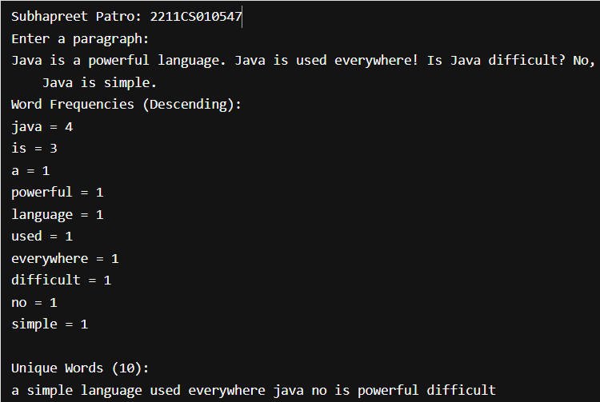
4.Remove Duplicates and Sort (List & Set)
Objective:
Given a list of integers with duplicates, write a Java program to:
1. Remove duplicates.
2. Sort the result in ascending order.
Requirements:
• Use List to accept input.
• Use Set (e.g., LinkedHashSet or TreeSet) to remove duplicates.
• Return a sorted list.
Input: [4, 2, 7, 2, 4, 9, 1]
Output: [1, 2, 4, 7, 9]

Solution:
import java.util.*;
public class RemoveDuplicatesAndSort {
public static void main(String[] args) {
// Step 1: Input list with duplicates
System.out.println("Subhapreet Patro: 2211CS010547");
List<Integer> inputList = Arrays.asList(4, 2, 7, 2, 4, 9, 1);
System.out.println("Original List: " + inputList);
// Step 2: Remove duplicates using TreeSet (automatically sorted)
Set<Integer> uniqueSortedSet = new TreeSet<>(inputList);
// Step 3: Convert back to List (if needed)
List<Integer> sortedList = new ArrayList<>(uniqueSortedSet);
// Step 4: Output result
System.out.println("Sorted List without Duplicates: " + sortedList);
}
}

Output:
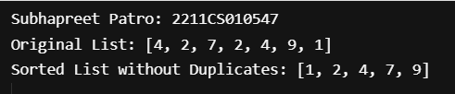

5.Employee Directory (Map & Custom Class)
Objective:
Create a program that stores and displays an employee directory using a Map where:
• The key is the department name.
• The value is a list of employee names in that department.
Requirements:
• Use HashMap<String, List<String>>.
• Provide options to add, search, and list employees by department.

Solution:
import java.util.*;

public class EmployeeDirectory {
// Map to store department and employee list
private final Map<String, List<String>> directory = new HashMap<>();
private final Scanner scanner = new Scanner(System.in);

public static void main(String[] args) {
System.out.println("Subhapreet Patro: 2211CS010547");
EmployeeDirectory ed = new EmployeeDirectory();
ed.runMenu();
}

// Main menu
public void runMenu() {
int choice;
do {
System.out.println("\n--- Employee Directory ---");
System.out.println("1. Add Employee");
System.out.println("2. Search by Department");
System.out.println("3. List All Departments and Employees");
System.out.println("4. Exit");
System.out.print("Choose an option: ");
choice = scanner.nextInt();
scanner.nextLine(); // consume newline

switch (choice) {
case 1 -> addEmployee();
case 2 -> searchByDepartment();
case 3 -> listAll();
case 4 -> System.out.println("Exiting...");
default -> System.out.println("Invalid choice! Try again.");
}
} while (choice != 4);
}

// Add employee to a department
private void addEmployee() {
System.out.print("Enter department name: ");
String department = scanner.nextLine().trim();

System.out.print("Enter employee name: ");
String employee = scanner.nextLine().trim();

// If department doesn't exist, create a new list
directory.putIfAbsent(department, new ArrayList<>());
directory.get(department).add(employee);

System.out.println("Employee added successfully.");
}

// Search and display employees in a department
private void searchByDepartment() {
System.out.print("Enter department name to search: ");
String department = scanner.nextLine().trim();

List<String> employees = directory.get(department);
if (employees == null || employees.isEmpty()) {
System.out.println("No employees found in this department.");
} else {
System.out.println("Employees in " + department + ":");
for (String emp : employees) {
System.out.println("- " + emp);
}
}
}

// List all departments and their employees
private void listAll() {
if (directory.isEmpty()) {
System.out.println("Directory is empty.");
return;
}

System.out.println("\nAll Departments and Employees:");
for (Map.Entry<String, List<String>> entry : directory.entrySet()) {
System.out.println("\nDepartment: " + entry.getKey());
for (String emp : entry.getValue()) {
System.out.println(" - " + emp);
}
}
}
}
Output:
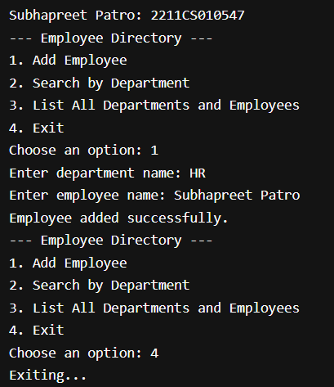
6.Design a real-time data handling system where:
• Sensors (Producers) continuously generate data and push it into a shared data queue (buffer).
A Processing Unit (Consumer) fetches data from the buffer for real-time processing and action

Solution:

import java.util.Random;
import java.util.concurrent.*;

// Sensor (Producer)
class Sensor implements Runnable {
private final BlockingQueue<Integer> dataQueue;
private final String sensorName;
private final Random random = new Random();

public Sensor(String sensorName, BlockingQueue<Integer> queue) {
this.sensorName = sensorName;
this.dataQueue = queue;
}

@Override
public void run() {
while (true) {
try {
int data = random.nextInt(100); // Simulated sensor data
dataQueue.put(data); // Blocking put
System.out.println(sensorName + " produced data: " + data);
Thread.sleep(500 + random.nextInt(500)); // Simulate interval
} catch (InterruptedException e) {
System.out.println(sensorName + " interrupted.");
break;
}
}
}
}

// Processing Unit (Consumer)
class ProcessingUnit implements Runnable {
private final BlockingQueue<Integer> dataQueue;

public ProcessingUnit(BlockingQueue<Integer> queue) {
this.dataQueue = queue;
}

@Override
public void run() {
while (true) {
try {
int data = dataQueue.take(); // Blocking take
System.out.println("Processing Unit consumed data: " + data);
process(data);
} catch (InterruptedException e) {
System.out.println("Processing Unit interrupted.");
break;
}
}
}

private void process(int data) {
// Simulated processing (can add ML, logging, alerts, etc.)
if (data > 80) {
System.out.println(">> ALERT: High value detected! (" + data + ")");
}
}
}

// Main class
public class RealTimeDataSystem {
public static void main(String[] args) {
BlockingQueue<Integer> dataQueue = new LinkedBlockingQueue<>(10); // Shared buffer

Thread sensor1 = new Thread(new Sensor("Sensor-1", dataQueue));
Thread sensor2 = new Thread(new Sensor("Sensor-2", dataQueue));
Thread processor = new Thread(new ProcessingUnit(dataQueue));

// Start threads
sensor1.start();
sensor2.start();
processor.start();

// Run for a fixed time (optional), then stop
Runtime.getRuntime().addShutdownHook(new Thread(() -> {
sensor1.interrupt();
sensor2.interrupt();
processor.interrupt();
System.out.println("System shutdown initiated...");
}));
}
}

Output:
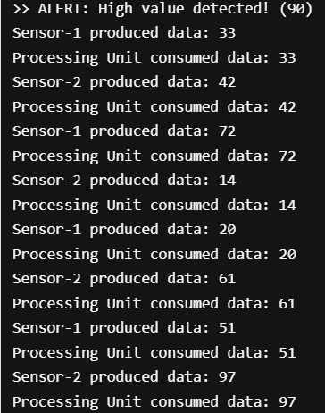

7.Online Food Delivery System Using Multithreading
In an online food delivery system, multiple customers place orders concurrently, and multiple delivery agents process and deliver those orders. Each order must be picked up from the restaurant and delivered to the customer.
Design a multithreaded system that simulates:
• Multiple customers (threads) placing food orders.
• Restaurants (shared resources) preparing food.
• Delivery agents (threads) picking up and delivering orders.
Solution:
import java.util.*;
import java.util.concurrent.*;

// Represents a food order
class Order {
private static int idCounter = 1;
private final int orderId;
private final String customerName;
private final String foodItem;

public Order(String customerName, String foodItem) {
this.orderId = idCounter++;
this.customerName = customerName;
this.foodItem = foodItem;
}

public int getOrderId() { return orderId; }
public String getCustomerName() { return customerName; }
public String getFoodItem() { return foodItem; }

@Override
public String toString() {
return "Order #" + orderId + " (" + foodItem + ") for " + customerName;
}
}

// Customer thread placing order
class Customer implements Runnable {
private final BlockingQueue<Order> orderQueue;
private final String customerName;
private final List<String> menu = List.of("Pizza", "Burger", "Sushi", "Pasta", "Tacos");

public Customer(String name, BlockingQueue<Order> queue) {
this.customerName = name;
this.orderQueue = queue;
}
@Override
public void run() {
try {
Random rand = new Random();
String food = menu.get(rand.nextInt(menu.size()));
Order order = new Order(customerName, food);
orderQueue.put(order); // Place order
System.out.println("[Customer] " + customerName + " placed " + order);
} catch (InterruptedException e) {
System.out.println("[Customer] " + customerName + " was interrupted.");
}
}
}

// Restaurant that prepares the food
class Restaurant {
public void prepareOrder(Order order) throws InterruptedException {
System.out.println("[Restaurant] Preparing " + order);
Thread.sleep(1000); // Simulate time to prepare food
}
}

// Delivery Agent thread
class DeliveryAgent implements Runnable {
private final BlockingQueue<Order> orderQueue;
private final Restaurant restaurant;
private final String agentName;

public DeliveryAgent(String name, BlockingQueue<Order> queue, Restaurant restaurant) {
this.agentName = name;
this.orderQueue = queue;
this.restaurant = restaurant;
}

@Override
public void run() {
while (true) {
try {
Order order = orderQueue.take(); // Pick order from queue
restaurant.prepareOrder(order);
System.out.println("[DeliveryAgent] " + agentName + " picked up " + order);
Thread.sleep(1000); // Simulate delivery time
System.out.println("[DeliveryAgent] " + agentName + " delivered " + order);
} catch (InterruptedException e) {
System.out.println("[DeliveryAgent] " + agentName + " was interrupted.");
break;
}
}
}
}

// Main class
public class FoodDeliverySystem {
public static void main(String[] args) {
System.out.println("Subhapreet Patro: 2211CS010547");
BlockingQueue<Order> orderQueue = new LinkedBlockingQueue<>(10);
Restaurant restaurant = new Restaurant();

// Start delivery agents
Thread agent1 = new Thread(new DeliveryAgent("Agent-1", orderQueue, restaurant));
Thread agent2 = new Thread(new DeliveryAgent("Agent-2", orderQueue, restaurant));
agent1.start();
agent2.start();

// Start customer threads
for (int i = 1; i <= 5; i++) {
Thread customer = new Thread(new Customer("Customer-" + i, orderQueue));
customer.start();
try {
Thread.sleep(700); // Delay between customers
} catch (InterruptedException e) {
e.printStackTrace();
}
}

// Shutdown logic after demo (optional)
new Timer().schedule(new TimerTask() {
public void run() {
agent1.interrupt();
agent2.interrupt();
System.out.println("System shutdown...");
}
}, 10000); // Stop after 10 seconds
}
}

Output:
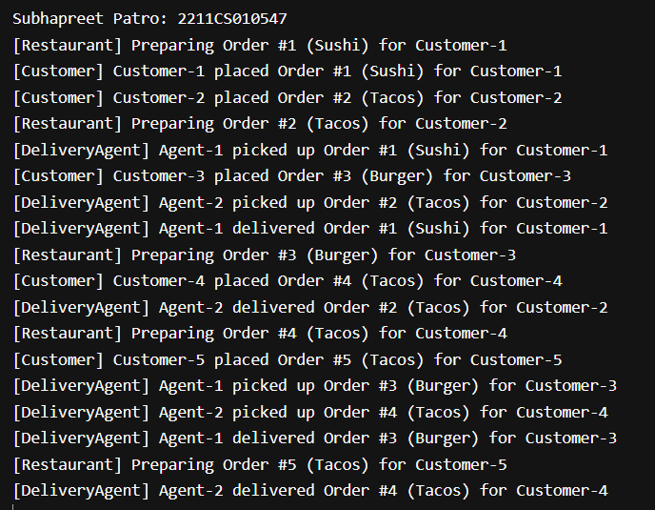
8. Remove duplicates from Array
Solution:
import java.util.*;

public class RemoveDuplicates {
public static void main(String[] args) {
System.out.println("Subhapreet Patro: 2211CS010547");
int[] arr = {4, 2, 7, 2, 4, 9, 1};

// Step 1: Convert array to List
List<Integer> list = new ArrayList<>();
for (int num : arr) {
list.add(num);
}

// Step 2: Use Set to remove duplicates
Set<Integer> set = new LinkedHashSet<>(list); // maintains insertion order

// Step 3: Convert back to array (optional)
int[] uniqueArray = set.stream().mapToInt(Integer::intValue).toArray();

// Output
System.out.println("Original Array: " + Arrays.toString(arr));
System.out.println("Array after removing duplicates: " + Arrays.toString(uniqueArray));
}
}
Output:
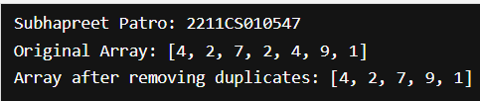

9. How to sort an array of objects
Hint:- Camparable & comparator interfaces

Solution:
import java.util.*;

class Student implements Comparable<Student> {
String name;
int marks;

Student(String name, int marks) {
this.name = name;
this.marks = marks;
}

@Override
public int compareTo(Student s) {
return this.marks - s.marks; // Ascending order
}

@Override
public String toString() {
return name + " - " + marks;
}
}

public class SortUsingComparable {
public static void main(String[] args) {
System.out.println("Subhapreet Patro: 2211CS010547");
Student[] students = {
new Student("Alice", 85),
new Student("Bob", 70),
new Student("Charlie", 92)
};

Arrays.sort(students); // Uses compareTo()

for (Student s : students) {
System.out.println(s);
}
}
}
Output:
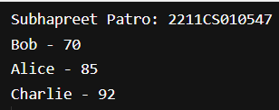

10. Find Higest & lowest Frequency elements of an array
Solution:
import java.util.*;

public class FrequencyFinder {
public static void main(String[] args) {
System.out.println("Subhapreet Patro: 2211CS010547");
int[] arr = {2, 3, 4, 2, 3, 3, 1, 5, 2, 5};
Map<Integer, Integer> freqMap = new HashMap<>();
for (int num : arr) {
freqMap.put(num, freqMap.getOrDefault(num, 0) + 1);
}
int maxFreq = Collections.max(freqMap.values());
int minFreq = Collections.min(freqMap.values());
List<Integer> maxFreqElements = new ArrayList<>();
List<Integer> minFreqElements = new ArrayList<>();

for (Map.Entry<Integer, Integer> entry : freqMap.entrySet()) {
if (entry.getValue() == maxFreq) {
maxFreqElements.add(entry.getKey());
}
if (entry.getValue() == minFreq) {
minFreqElements.add(entry.getKey());
}
}
System.out.println("Original Array: " + Arrays.toString(arr));
System.out.println("Frequency Map: " + freqMap);
System.out.println("Highest Frequency: " + maxFreq + ", Elements: " + maxFreqElements);
System.out.println("Lowest Frequency: " + minFreq + ", Elements: " + minFreqElements);
}
}
Output:
